Verizon One Talk- Call Features
- Direct Transfer- 2 options:
  - Simply press the speed dial button (with or without the caller on hold)
  - Select Transfer button>>Dial Ext or Number>>Press Direct Button
- Consultative Transfer:
  - Press Transfer Button>>Dial Ext or Number>>Press Consult Button>>Press Transfer (after consulting)
- Send Caller Straight to Voicemail:
  - Press Transfer Button>>Dial **55 + Ext (or number)>>Direct
- Conference Calls:
  - Place Call on hold>> Press New Call (or 2nd line)>>Place 2nd Call>>Once answered,>>Click more than conference (repeat to add up to 6 callers maximum)
- Park & Retrieve call:
  - While on Call>>Click More, then Park>>Dial Extension, then #>>Walk to phone where you parked call, hit retrieve then pick up the receiver
  - To park to own extension just click #>>pick up call on One Talk App (or vice/versa)
  - Calls can be retrieved by dialing **88 + extension+#
- Remote Group Pickup:
  - Enables you to remotely pick up someone’s ringing line
  - Dial **98 + Extension + #

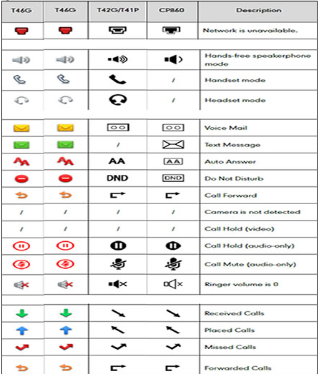
- Set up Voice Mail
  - Press the envelope key on your phone>>select preferred language>>create 4-7-digit password>>record your name or business name>>select either personalized or standard greeting.
  - Press 7 to delete messages and 9 to save
  - To change your recorded message, go to personal options (4)>>Greetings (3)>>Personal Greeting (3)

- Speed dial configuration of a line key:
- 1. Press and hold an unused line key (for about five seconds)
- 2. Use the right arrow key or the Switch soft key to scroll through the type of line keys available until you locate Speed Dial 3. Scroll to complete each of the following fields:
- • Account ID: Select the phone line to associate with this line key
- • Label: Enter the name you would like displayed on the line key label
- • Value: Enter the phone number you would like this line key to dial
- 4. Press the Save soft key to accept your changes. You can now use this line key to speed dial this contact.

